Chapter 1

Introduction

Majority of businesses have yet to establish their businesses on the internet. People are still skeptical about applying online and would rather do it traditionally. The main problem of applying for jobs online is that users, both employees who are unemployed or who have experience and companies, cannot fully trust the information that is given to them (Kuhn & Mansour, 2013). A study shows that unemployed workers who search for jobs tend to be unemployed longer compared to those who search traditionally . The internet is a great medium for effective communication making it a valued method of recruitment as stated in a study done in Germany by the human resources management. It was mentioned that the reason for its appraisal is because it reaches young applicants who are highly qualified. Numerous online job portals are ready and available for users to seek for opportunities. These opportunities can be either accessed through company websites, job searching websites, social media notices, etc. (Mochol, Wache, & Nixon, 2007). The matching process of job searching is affected by the information that is available on the internet. Since the internet is a social space, the flow of information on available occupations are much harder to encounter which could lead to the user using up most of their time searching with only a few good results (Fountain, 2005). By tackling this problem, giving the user the ability to access what they want, the user will be able to no waste their time searching. The users could instead apply for multiple jobs with ease with their times in order to maximize their possibility of getting accepted.

Business Rules

* Non Registered Users may browse the website immediately without registration
* Non Registered Users are only limited to browsing the website
* Users must agree to the website’s Terms of Service
* Registered Users can upload their paperwork
* Users can use the search bar to input keywords
* Registered Users have a limitation of 1 account per email
* Companies have no restrictions to how many users they can list
* Users have no limitation of submission of job applications
* Paperwork are only accessible by the company it is submitted to and the user that submitted it
* Companies must provide a result of users’ application
* Users may contact the developers for issues regarding the website or company
* Users may message the companies for any additional questions
* Companies cannot provide false information
* Users must be at least 15 to submit job applications
* Users may leave a comment on the company’s page on the website
* User paperwork must be scanned instead of photographed
* Companies can blacklist users for job application
* Users can reapply for companies if they are not blacklisted

Business Process

The users have the option to create an account. The users can search for occupations/employees on the website. The user will have the option to either be an employee or employer. If the user is registered, then their search results will already be filtered based on their profile; non registered users can still filter but the strokes will not be saved. After the results are shown, the user can apply for the job or recruit the employee. Non registered users cannot apply.

Business Process Diagram

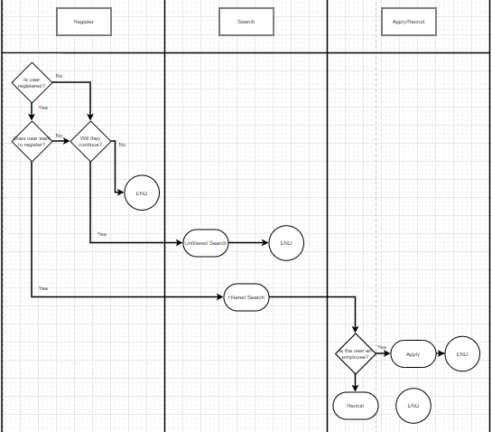

Objectives of the Study

The objectives of the study is to create a website that is simple for fresh graduates and unemployed users to use where the information that is uploaded can be trusted. The website should also immediately show results of job opportunities/employees to the user.

Chapter 2

Problems Encountered

The problem of online job searching is that it is difficult for users to search for jobs since not all websites and applications integrate a function that will match the user’s preference and qualifications. The sites that do have that function still makes the user search for them instead of being an automatic function.

Proposed Solution

The website we will create will create results based on the user’s profile. With this, their search page will automatically update to their preferences of occupations.

Functional Requirements

* User’s information including job qualification and classification.
* Information security
* Job applications/offer posting

Search will be based on user profile

NonFunctional Requirements

* Minimalistic, user friendly UI
* Large data capacity
* Fast page loading
* Fast data computation

References:

https://sci-hub.se/https://onlinelibrary.wiley.com/doi/abs/10.1111/ecoj.12119

https://sci-hub.se/https://academic.oup.com/sf/article-abstract/83/3/1235/2234774

https://sci-hub.se/https://link.springer.com/chapter/10.1007/978-3-540-72035-5_23

Work Division

As-il, Castillo - Chapter 1

Baleña, Bombarda - Chapter 2